**Project:** Facilities

**General information:**

We have 7 projects configured in the application:

* Front end with Angular named as “FacilitiesClient”: Client end application
* Front end with Angular named as “FacilitiesCustomer”: Customer end application
* Front end with Angular named as “FacilitiesVendor”: Vendor end application
* Class library project : “BussinessEntities”: Where the model is defined for the service
* Class library project : “UnitOfwork”: Where the actual code for interacting with the database is put
* Class library project : “DataModel”: Where the entity classes are generated
* Services as backed named as: “FacilitiesServices”: This project handles the rest based services

**Guidelines to setup the environment both the projects to host on IIS:**

* Please install Visual Studio 2015 or above version for setting up the project.
* Please download and install nodejs from <https://nodejs.org/en/download/>. Please install the “Recommended for most users” only and not the “Current”.
* Please open the Visual Studio “ONLY in administrator mode”
* Please open the solution of the application inside the “Facilities” folder

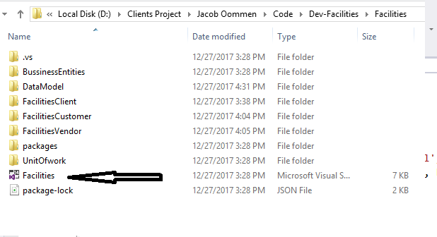

After the solution is loaded, you will be able to see all the projects in it:

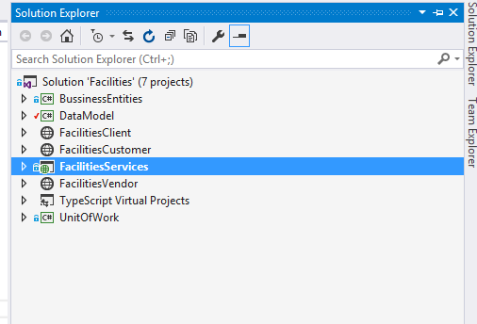

* Right click ONLY on the “FacilitiesServices” project and click on “Set as Startup Project” node.

**To run the Services POCAPI project:**

* Please hit f5 or run the project using visual studio
* It will open the browser with services running

**To run the Angular POC project:**

* Please open node command prompt ONLY in admin mode
* Please check that you have angular CLI updated for angular 5 using below commands:

Command to run in node cmd prompt: “**ng –version**”

Desired Output: “**Angular CLI: 1.5.5**”

If CLI is not updated, please update the angular cli using these commands on node cmd prompt and again check:

npm uninstall -g angular-cli

npm uninstall -g @angular/cli

npm install -g @angular/cli@latest

Once we have got the angular CLI updated for angular 5, below mentioned step when performed for each angular application individually, will run each application

* Please go to the root directory of the angular project inside folder explorer. Copy the full path of this location.
* Please navigate to this path in node command prompt: “**cd path-to-your-angular-application-copied-from-file-explorer**”

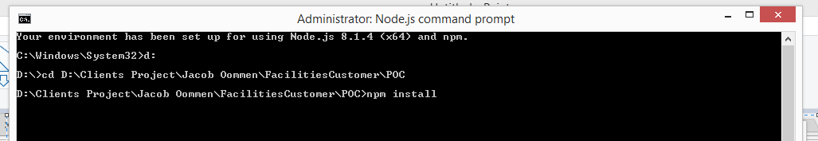

* Please type “**npm install**” and hit enter: This will install the packages needed for the application to run
* Please type “**npm install --save @angular/material @angular/cdk**” and hit enter
* Please type “**npm install --save @progress/kendo-angular-grid @progress/kendo-angular-dropdowns @progress/kendo-angular-inputs @progress/kendo-angular-dateinputs @progress/kendo-data-query @progress/kendo-angular-intl @progress/kendo-angular-l10n @progress/kendo-drawing @progress/kendo-angular-excel-export @angular/animations**” and hit enter
* Please type **“npm install pdfmake”** and hit enter
* After successfully executing the above command, please type “ng serve”. This will start running the application. In the example shown below the application is running on : http://localhost:4200/
* 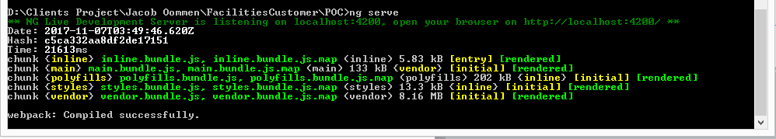

NOTE:

“globalvariable.ts” file is present in all 3 projects at this location: “**ProjectRootDirectory**\src\app\shared”

Please make sure that it has correct service url in this variable: “baseAPIUrl”

readonly baseAPIUrl: string = 'http://localhost:58983//API/';// URL for services running on local computer